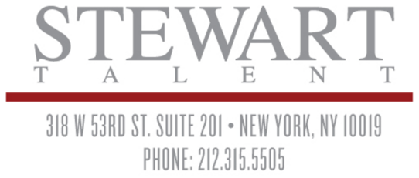
LAUREN SCHAFFEL
SAG-AFTRA/ AEA
310-592-4046
laurenschaffel111@gmail.com
laurenschaffel.com
Instagram: laurenschaffel111

HAIR: Brown | HEIGHT: 5’2”
EYES: Brown | SIZE: 0
 | VOCAL RANGE: Coloratura Soprano (D3-Eb5)
FILM: (Partial list)

BATSH*T BRIDE | SUPPORTING | STREAMING ON AMAZON  DIR. JONATHAN SMITH
LOYALTY | LEAD | STRAMING ON AMAZON  DIR. PATRICK WHITEHEAD
REVENGE OF THE GREEN DRAGONS  *Exec. Prod. Martin Scorsese | SMALL SUPP. | IM GLOBAL PRODUCTIONS  DIR. ANDREW LAU/ ANDREW LOO
ADMISSION  *Scene with Tina Fey | SMALL SUPP. | FOCUS FEATURES  DIR. PAUL WEITZ
MY DEAD BOYFRIEND  *Scene with Heather Graham | SMALL SUPP. | COHEN MEDIA GROUP  DIR. ANTHONY EDWARDS

TELEVISION: (Partial list)

THE MARVELOUS MRS. MAISEL  IT’S YOUR VALENTINE, CHARLIE BROWN | CO-STAR  LUCY/ VO | AMAZON  ABC PRODUCTIONS
SITUATION COMEDY (Pilot)  *Exec. Prod. Sean Hayes | SERIES REGULAR | NBC PRODUCTIONS
STILL STANDING | GUEST STAR, recurring | TWENTIETH CENTURY FOX
WILL AND GRACE | CO-STAR | NBC PRODUCTIONS

THEATER: (Partial list)

WAIT UNTIL DARK  *Co-production with Arizona Theater Company | SUPPORTING | GEVA THEATER, NY  DIR. DAVID IRA GOLDSTEIN
LOVE/FANTASY  *Audience Favorite Award | LEAD | THE WILD PROJECT, NY  DIR. ARIELLE SOSLAND
OBSERVANCE | LEAD | BANK STREET THEATER, NY  DIR. SUSANNA WOLK
BASKET WEAVER | SUPPORTING | PLAYWRIGHTS HORIZONS, NY  DIR. MICHAEL J. BURG
LUDLOW FAIR | LEAD | THE BARROW GROUP, NY  DIR. AUSTIN PENDLETON
CHARLIE BROWN CHRISTMAS | LEAD/ LUCY | THE SECRET THEATRE, NY  DIR. ASHLEY GUNSTEENS
GLORIA  *Staged reading | SUPPORTING | PLAYWRIGHTS HORIZONS, NY  DIR. ED ISKANDAR
THE GLASS MENAGERIE | LEAD/ LAURA | THE BARROW GROUP, NY  DIR. AUSTIN PENDLETON
MEET VICTORIA  *Ongoing program | LEAD | LOWER EAST SIDE TENEMENT MUSEUM, NY  DIR. JESSICA UNDERWOOD VARMA

COMMERCIALS: List Upon Request

VOICEOVERS: List Upon Request

TRAINING:
BA, COMPARATIVE LITERATURE AND THEATER, COLUMBIA UNIVERSITY, NYC
Acting: Matt Newton, Bob Krakower, Lee Brock, Seth Barrish, Austin Pendleton, Ted Sluberski
Improv: Upright Citizens Brigade, Groundlings Theater
Singing: Manhattan School of Music Professional Musical Theater Workshop, CAP 21 Conservatory, Mary Saunders Barton
Dance: Steps on Broadway

SKILLS:
Dialects: Russian, Spanish, Irish, German, French, RP British; Singer: Classical, Musical Theater, Pop/Rock; Other: Costumed Interpreter and Educator at the Lower East Side Tenement Museum, Advanced Yogi

